An Introduction to Linear Algebra Using Python: Part II

Dr. Steven L. Richardson
Howard University and Harvard University
Tuesdays 2:00 p.m. – 3:35 p.m. (Zoom Lecture)
Tuesdays 3:35 p.m. – 4:30 p.m. (Zoom Recitation Session)
srichards22@comcast.net

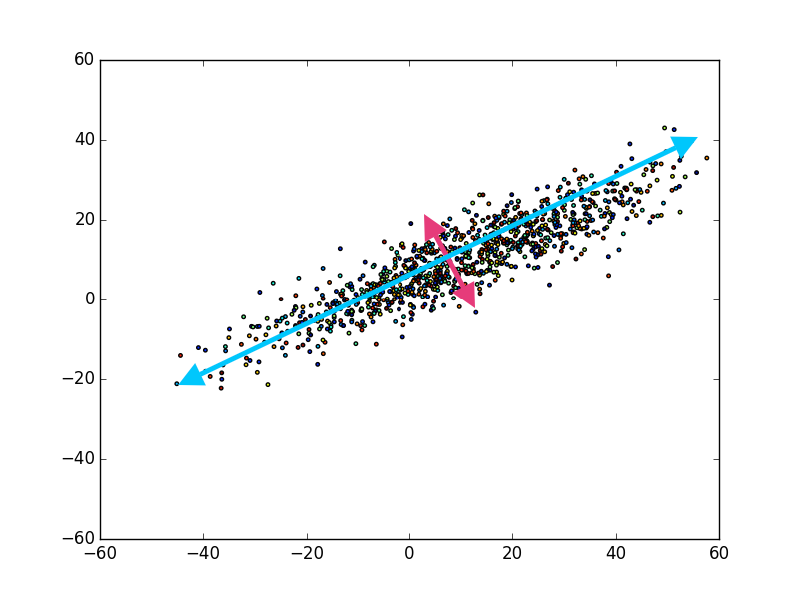
Linear algebra can help us better understand important problems in data science like in this general example.

This course is a continuation of the course “An Introduction to Linear Algebra Using Python’’(https://www.youtube.com/playlist?list=PL0CLfRiRFyPBIqzvtFUeG9vPQ-uVq4I-Q) and it covers the following topics: linear transformations, orthogonal matrices, the Gram-Schmidt process, QR-decomposition, eigendecomposition, symmetric matrices, singular vectors and values, the singular value decomposition problem, covariance matrices, and an introduction to principal component analysis. NumPy (a numerical library of Python) is a very convenient package which is used to code both vectors and matrices and we will use some simple applications of it throughout this course to reinforce the important concepts and examples of linear algebra.

This course is supported by the National Science Foundation Science and Technology Center for Integrated Quantum Materials, NSF Grant No. DMR-1231319

Lecture 1 (Tuesday, June 7, 2022): Review of Properties of Vectors and Matrices: I

Lecture 2 (Tuesday, June 14, 2022): Review of Properties of Vectors and Matrices: II

Lecture 3 (Tuesday, June 21, 2022): Projections and the Gram-Schmidt Process

Lecture 4 (Tuesday, June 28, 2022): The QR Decomposition of Matrices

Lecture 5 (Tuesday, July 5, 2022): The Eigendecomposition Problem: Part I

Lecture 6 (Tuesday, July 12, 2022): The Eigendecomposition Problem: Part II

Lecture 7 (Tuesday, July 19, 2022): The Eigendecomposition Problem: Part III

Lecture 8 (Tuesday, July 26, 2022): The Eigendecomposition Problem: Part IV

Lecture 9 (Tuesday, August 2, 2022): An Introduction to the Singular Value Decomposition (SVD): Part I

Lecture 10 (Tuesday, August 9, 2022): An Introduction to the Singular Value Decomposition (SVD): Part II

Lecture 11 (Tuesday, August 16, 2022): An Introduction to the Singular Value Decomposition (SVD): Part III

Lecture 12 (Tuesday, August 23, 2022): Covariance Matrices

Lecture 13 (Tuesday, August 30, 2022): An Introduction to Principal Component Analysis (PCA)

